Evidence Based Argumentation
NSTA Conference Presentation
Activity 1: Claim-Evidence Game
- In the left column, fill in the blank to create a claim.
- Pass your paper to the person to your right.
- The person on your left will pass you a paper. Write a piece of evidence for their claim.

Claim: a statement that you can debate or defend | Evidence: An example that proves the claim is true
EX: Evidence is demonstrated by the fossil record, which shows the remains of organisms left behind. | This claim is true based on the evidence that  In each fossil layer a variation of a horses leg can be seen changing over time from 3 leg bones to 1 leg bone
Evolution is demonstrated by __________________________, which shows an organism structural similarities | This claim is true based on the evidence that  ________________________________________________________  ________________________________________________________  ________________________________________________________  ________________________________________________________
Evolution is demonstrated by ________________________, which are structures that remain but are not used any longer. | This claim is true based on the evidence that  ________________________________________________________  ________________________________________________________  ________________________________________________________  ________________________________________________________

MCAS Question Name: _________________
Date: __________________
1) The fossil record supports which of the following descriptions of the evolution of life on Earth?
 | A. | Life first appeared with the diversity found today.
 | B. | The importance of natural selection diminished over time.
 | C. | Complex organisms evolved from more simple organisms.
 | D. | Large organisms appeared before single-celled organisms.

Answer ______ best supports the claim ________________________________________________________
Because __________________________________________________________________________________.

2) Frogs, lizards, and birds all have a similar arrangement of bones in their limbs. Which of the following does this similarity most likely indicate about these animals?
 | A. | They move in the same way.
 | B. | They have a common ancestry.
 | C. | They evolved at the same time.
 | D. | They are comparable in size as adults.

Answer ______ best supports the claim ________________________________________________________
Because __________________________________________________________________________________.

8) Which of the following provides the most conclusive evidence that organisms of two different species share a common ancestor?
 | A. | They live in the same ecosystem.
 | B. | They reproduce at the same time.
 | C. | They have similar DNA sequences.
 | D. | They have similar body movements.

Answer ______ best supports the claim ________________________________________________________
Because ____________________________________________________________________________________

Activity 2: Choosing the Best Evidence Mini Debate
- Read the provided text, claim, and evidence
- In a group of three, assign each person a piece of evidence.
- Each person will have one minute to stand and make a speech describing why their evidence best proves the claim.
  - In the first column, write two reasons why your evidence best proves the claim. Use these reasons to make your speech (If you need help, refer to the HINT CARDS.)
  - During your opponent’s speech, record their reasons in the second and third columns
- As a group decide who won the debate

Claim: All organisms came from a common ancestor and have changed over time to adapt to their environment.

Evidence 1: Vestigial and Homologous Structures

Evidence 2: Fossil Records

Evidence 3: DNA similarities

Choosing the Best Evidence Mini Debates – Which evidence best proves the claim is true?
Before the Mini Debate write the two reasons you believe your evidence best proves the claim is true.
 | My evidence (Evidence __) best proves the claim is true because… | My 1st opponent argues evidence ___ best proves the claim is true because… | My 2nd opponent argues evidence ___ best proves the claim is true because…
1st Reason evidence best proves the claim is true.

2nd Reason evidence best proves the claim is true.

Activity 3: Counterargument Class Challenge
- Read the text “Real Life Examples of Charles’ Law and Boyles Law”
- Join a group at one of the two posters containing a claim for this topic.
- As a group, write a piece of evidence from the text to support your claim.
- Go to the opposing poster and read the claim and evidence. Write a counterargument for this claim and evidence.
- Return to your poster and read the counterargument. Write a response to this counterargument.

Claim (A statement that you can debate or defend)
(copy from poster)

Evidence (Evidence from the text and analysis of how it proves the claim)
The evidence that_______________________________________________________________________________

demonstrates _______________________________________________________________________________________

because ______________________________________________________________________________________________

Counterargument (A reason why the claim and evidence are wrong)
Summarize their argument
The fact that ________________________________________________________________ is not true because

_________________________________________________________________________________________________________.

OR
Summarize their argument

The idea that ___________________________________________________ is less important than the fact

that ___________________________________________________________________________________________________.

Response (Explains how the counterargument does not harm the claim)
Summarize their counterargument
The fact that __________________________________________________________________ is not true because

________________________________________________________________________________________________________.

OR
Summarize their counterargument

The idea that ___________________________________________________ is less important than the fact

that ____________________________________________________________________________________________________.

Evidence for Evolution
Vestigial Structures:
A vestigial structure is an anatomical feature that no longer seems to have a purpose in the current form of an organism of the given species. Often, these vestigial structures were organs that performed some important function in the organism at one point in the past. However, as the population changed due to natural selection, those structures became less and less necessary until they were rendered pretty much useless. While most of these types of structures would probably disappear over many generations, some seem to keep being passed down to offspring even though they have no known function.
Examples of Vestigial Structures:
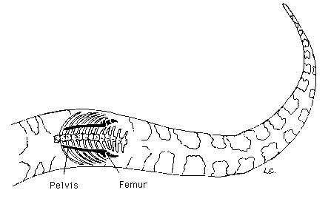
Vestigial legs are a clue that snakes descended from lizards. Over 100 million years ago, some lizards happened to be born with smaller legs, which, in certain environments, helped them move about unencumbered. As generation after generation survived and reproduced, this new form flourished. Over time, all members of the group were born with shorter legs, and eventually with no legs at all. Almost. The ancestor of boas and pythons retained very small vestigial legs, a trait passed on to its descendants, including the reticulated python seen here.
http://www.amnh.org/exhibitions/past-exhibitions/darwin/evolution-today/how-do-we-know-living-things-are-related/vestigial-organs
http://nitro.biosci.arizona.edu/courses/EEB182/Lecture02/figures/snake.gif

Homologous Structures
Homologous structures are parts of the body that are similar in structure to other species' comparative parts. These similarities are evidence that life on Earth has a common ancient ancestor that the diverse species have evolved from over time. The common ancestry of the species can be seen in the structure and development of these homologous structures, even if their function is different.
The more closely the organisms are related, the more similar the homologous structures between organisms. Most examples of homologous structures revolve around the limbs of the species being compared. The bone structure within those limbs are similar between closely related species.

Examples of Homologous Structures
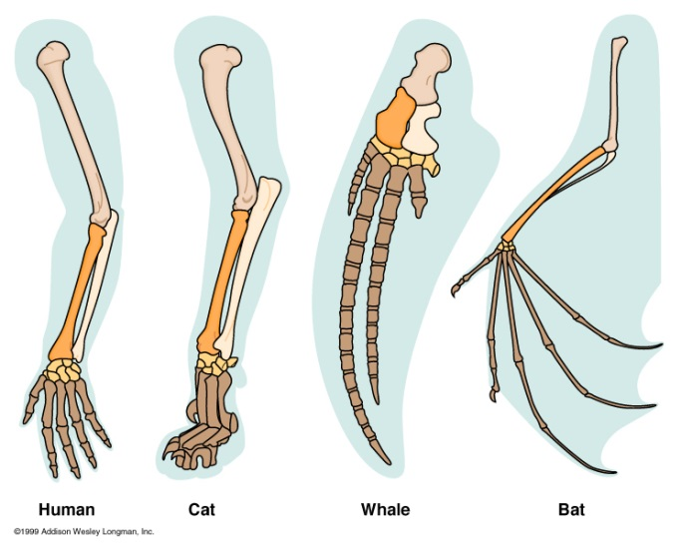
Many mammals have similar limb structures. The flipper of a whale, the wing of a bat, and the leg of a cat are all very similar. All of the mentioned species have a large upper arm bone and the lower part of the limb is made up of two bones - a larger bone on one side and a smaller bone on the other side. All of the species also have a collection of smaller bones in the "wrist" area that lead into the long "fingers" or phalanges.
Even though the bone structure in these limbs of the mammals are very similar, the function of the limb itself is very different. The homologous limbs can be used for flying, swimming, walking, or everything humans do with their arms. These functions evolved through natural selection as the common ancient ancestor underwent speciation to make all of the diversity we have on Earth today.
http://preachrr.files.wordpress.com/2011/01/forelimb_homology.jpg
http://evolution.about.com/od/evidence/a/Homologous-Structures.htm

Evidence for Evolution in DNA
DNA has only come to be understood over the last century. The technology has been improving and has allowed scientists to not only map out entire genomes of many species, but they also use computers to compare those maps. By entering genetic information of different species, it is easy to see where they overlap and where there are differences.
The more closely species are related on the phylogenetic tree of life, the more closely their DNA sequences will overlap. Even very distantly related species will have some degree of DNA sequence overlap. Certain proteins are needed for even the most basic processes of life, so those selected parts of the sequence that codes for those proteins will be conserved in all species on Earth.
http://evolution.about.com/od/Microevolution/a/Dna-And-Evolution.htm
DNA Example:
The wolf and dog share an almost identical genetic makeup. The two species share 78 of the same chromosomes. Their mitochondrial DNA (which is more preserved) makeup is only different by 0.2 percent or less. .
http://www.ehow.com/about_6360837_wolves-dogs-same_.html

