Cuba Embargo Affirmative

Cuba Embargo Affirmative – Table of Contents

Summary 3
Picture Glossary 4-6

First Affirmative Speech
1AC 7-10

Additional Evidence and Answers to Negative Arguments
Public Health Advantage
Answers to: Public Health is Strong in Cuba 11

Solvency
Answers to: No US/Cuban Trade 12
Answers to: Regime Controls Trade 13

Answers to: Government Repression Turn
Embargo Makes Government More Popular 14
Lifting Embargo Promotes Political Reforms 15
Trade Promotes Democracy 16

Answers to: Tourism Turn
Embargo Puts Worse Strains on Cubans than Tourism Would 17
Tourism Helps Cuba’s Economy 18

Summary

This affirmative case argues that the United States should lift its economic embargo on Cuba.

There are three main reasons why allowing trade, travel, and economic engagement with Cuba is a good idea:

First, the existing restrictions on trade limit the amount of medical goods that are available in Cuba – which has created a public health crisis.

Second, the embargo has strengthened the regime by allowing the Cuban government to scapegoat the United States for suffering of its people – improving economic conditions in Cuba would allow its people to focus on asserting their rights.

Third, the embargo is extremely unpopular and gets in the way of the United States’ ability to co-operate with Latin America – the ability to co-operate with Latin America is essential to work out solutions to several problems like nuclear proliferation and global climate change.

Picture Glossary
Picture 1 | Picture 2 | Term/Phrase | Definition | Example | Non Example
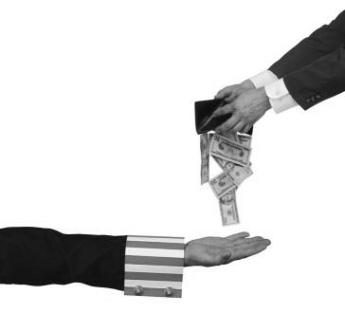 | 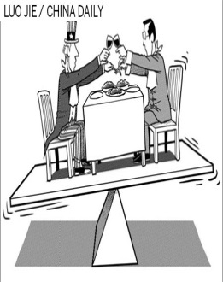 | Economic Engagement | A foreign policy strategy which seeks to increase ties between countries through economic interaction. | The US trying to find ways to increase trade with a country it wanted to get closer to politically. | If the U.S. decided to build a national monument in Venezuela to commemorate the life of former President Hugo Chavez.
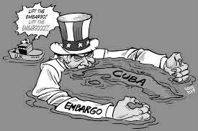  Cuban Embargo (current) | 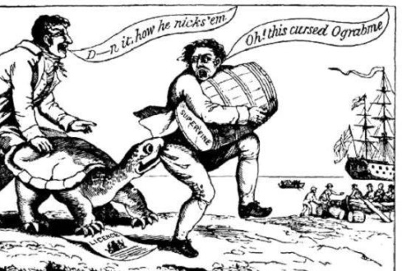Embargo Act of 1807 | Embargo/ Sanctions | Trade restrictions put in place against target countries with the aim of discouraging certain behaviors like human rights violations or military build-up. | After Burma’s military took over and oppressed their people the US will not sell them weapons. | The US charges Japanese car makers an extra 2.5% to import their cars (example of a duty)
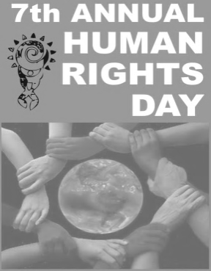 |  | Human rights | Basic, fundamental rights to which every person is entitled because they are human beings. | It is a human right to be given a fair trial and to be judged as equally as anybody else under the law. | It is not a human right to hurt another person who poses no threat to you.

Picture 1 | Picture 2 | Term/Phrase | Definition | Example | Non Example
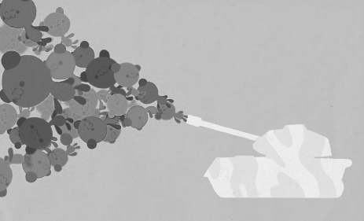 | 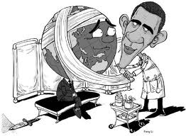 | International Influence/ Soft Power | A persuasive approach to international relations, typically involving the use of economic or cultural influence. The ability of a nation to persuade other nations to adopt changes by modeling good behavior, rather than the use of force or power. | Germany is forming a very green energy plan for the country and at the same time it is trying to encourage the USA and other European nations to adopt the same type of green energy plan | America going into Vietnam to try and stop them from forming a socialist or communist government by using our military power is an example of something that isn’t soft power
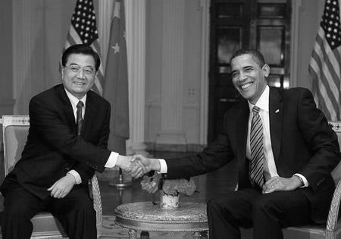 | 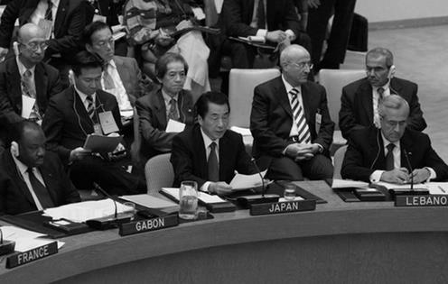 | International Relations | The relationships that dictate interactions between countries, their governments, and their people. | Our trade policy. | State taxes are a domestic issue and show nothing about international relations

Picture 1 | Picture 2 | Term/Phrase | Definition | Example | Non Example
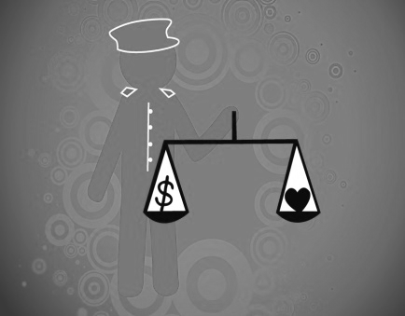 | 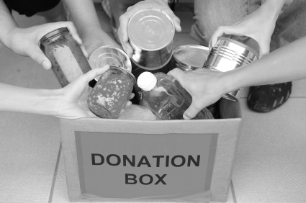 | Moral obligation | An obligation arising out of considerations of right and wrong or a sense of duty or priority imposed by moral standards. | If we have extra money then we should give back and donate money to other people in need. | Buying all of your friends Gucci sunglasses.
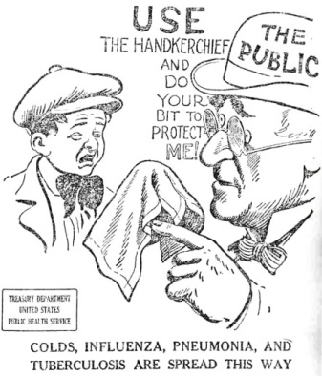 | 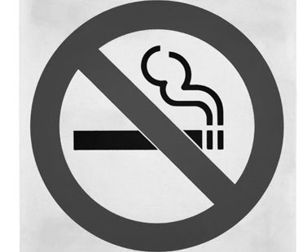 | Public Health | An organized effort of a society to improve the health and lifespan of its people. | Creating health clinics which provide free checkups in neighborhoods that cannot afford health care. | Building a trash dump in your neighborhood.
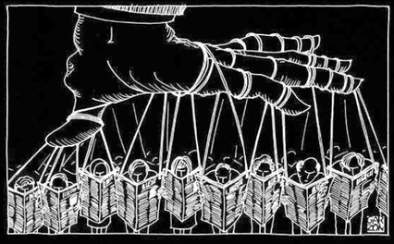 | 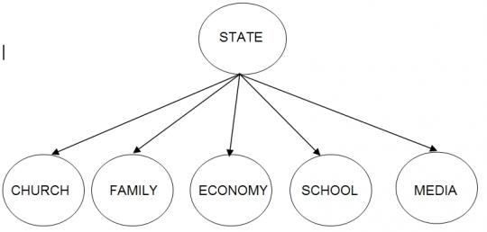 | Totalitarianism | A political system in which the state holds total authority over its society and seeks to control all aspects of public and private affairs. | In Cuba you can be put in prison for saying something the government does not like. | In the US you can say anything and do anything you like so long as it does not injure another person.

1AC 1/4

First, we will explain the current state of the United States’ relationship with Cuba:

Despite small changes, United States maintains an embargo that restricts the flow of goods like medical supplies into Cuba.

Guzmán, Emmy award winning journalist, 2013
(Sandra, “Jay-Z and Beyoncé's trip to Cuba isn't the problem, the embargo is,” CNN, May 8, Online: http://www.cnn.com/2013/05/07/opinion/guzman-beyonce-jay-z-cuba/index.html)

The few but very influential pro-embargo lobby have put a stranglehold on a lucid discussion surrounding Cuba. Five decades of failed policy later, our nation is being held hostage unable to have a cogent discussion on anything Cuba-related.¶ The U.S. embargo has not and will not work. Put in place in 1962 by President John F. Kennedy, the policy is stuck in a time warp that has nothing to do with modern-day reality. The most enduring embargo in modern day history is a remnant of a Cold War past when the Soviet Union was the enemy and the world was on the brink of nuclear war. The thinking was that financial sanctions, which included a ban on travel by American citizens, would collapse the island economy and force people to revolt against Fidel Castro.¶ Over the years, these sanctions have been eased or toughened depending on political winds. In 1992, disgraced New Jersey Rep. Robert Torricelli was behind one the cruelest acts which banned, among many things, food and medicine sales to Cuba and prevented Cuban-American families from sending cash to their relatives. These were tough times and seeing many friends and families suffer because they couldn't visit their elderly mothers more than once every three years, or being prevented from sending them needed supplies, was very painful. Restrictions have eased under President Barack Obama but there is still a major ban.¶ Enter Jay Z and Beyoncé.¶ It's 2013 and we need to debate Cuban policy earnestly. Members of Congress must stop the cowardice around the issue and stop humoring the delusions of passionate folks stuck in the 1960s for political votes and favor. The pro-embargo folks are ignoring the policy's epic failure and fail to recognize that U.S. policy has played into the hands of the Castro brothers, who have sinisterly used it to make the case to their people that if Cuba is starving and the island economy can't grow, it's because of this U.S. policy.

1AC 2/4

Second, we will explain how the economic embargo on Cuba hurts public health:

The shortage of medical supplies and technologies imposed by the embargo significantly undermines the quality of Cuba’s healthcare system.

Xinhua News, 2012
(“Cuban healthcare weakended by U.S. embargo,” 11/28, Online: http://news.xinhuanet.com/english/health/2012-11/28/c_132004531.htm)

Cuban medical authorities said on Tuesday a 50-year trade embargo imposed by the United States has severely undermined the country's healthcare system.¶ Cuban hospitals suffer restrictions in acquiring imported medical consumables and medicine, advanced medical technology and latest scientific information, officials said.¶ The public Institute of Cardiology and Cardiovascular Surgery, where thousands of people receive free medical care every year from international specialists, is financially strained by the embargo.¶ "We must find alternatives that sometimes include purchasing from distant markets, buying from third parties, which means higher prices for these products," said Director of the institute Dr. Lorenzo Llerena.¶ He added some equipments were simply unattainable, "because they are manufactured in the United States."¶ The embargo has caused Cuba a loss of more than 200 million dollars in the medical sector alone by 2011, representing a significant impact on the tiny Caribbean nation, according to official figures.¶ John Rhodes, a patient, told Xinhua that Cuba had made a great effort for the benefit of all its citizens.¶ "It provides us free medicine across the country, which is highly expensive around the world," he said, adding "due to the U.S. embargo, sometimes we do not have all the raw materials and tools to solve certain problems immediately."¶

1AC 3/4

These shortages contribute to massive loss of life in Cuba – we have a moral obligation to lift the embargo.

Eisenberg, former Professor Emeritus of Social Medicine and Psychology at the Harvard Medical School, 1997
(Leon, “The sleep of reason produces monsters – human costs of economic sanctions,” The New England Journal of Medicine, 336:17, pgs. 1248-1250, ProQuest)

Thus, three unusual outbreaks of medical conditions -- neuropathy, self-inflicted disease, and injuries caused by rioting -- stemmed from U.S. economic sanctions. The sanctions may be aimed at Fidel Castro, but the victims are the ordinary citizens of Cuba. Castro looks as well fed as ever. Economic sanctions afflict civilians, not soldiers and not the leaders of autocratic societies. Yet the United States continues to employ such sanctions against dictators (or at least those dictators it suits present policy to condemn). When the sanctions are applied, they are all-encompassing. The interdicted trade with Cuba includes visits by medical delegations and the mailing of medical journals such as this one. Whom do medical journals empower, dictators or doctors? Can freedom be defended by suppressing information any more than by interrupting food supplies or drugs?¶ Iraq is an even more disastrous example of war against the public health. Two months after the end of the six-week war, which began on January 16, 1991, a study team from the Harvard School of Public Health visited Iraq to examine the medical consequences of sanctions imposed after the armed conflict. The destruction of the country's power plants had brought its entire system of water purification and distribution to a halt, leading to epidemics of cholera, typhoid fever, and gastroenteritis, particularly among children. Mortality rates doubled or tripled among children admitted to hospitals in Baghdad and Basra. Cases of marasmus appeared for the first time in decades. The team observed "suffering of tragic proportions. . . . [with children] dying of preventable diseases and starvation."5 Although the allied bombing had caused few civilian casualties, the destruction of the infrastructure resulted in devastating long-term effects on health.¶ An international group supported by the United Nations Children's Fund (UNICEF) carried out a more comprehensive study five months later by interviewing members of households selected to represent the Iraqi population.6 The age-adjusted relative mortality rate among children in the eight months after the war, as compared with the five years before the war, was 3.2. There were approximately 47,000 excess deaths among children under five years of age during the first eight months of 1991. The deaths resulted from infectious diseases, the decreased quality and availability of food and water, and an enfeebled medical care system hampered by the lack of drugs and supplies.¶ The Cuban and Iraqi instances make it abundantly clear that economic sanctions are, at their core, a war against public health. Our professional ethic demands the defense of public health. Thus, as physicians, we have a moral imperative to call for the end of sanctions. Having found the cause, we must act to remove it. Continuing to allow our reason to sleep will produce more monsters.

Thus, we propose the following plan:

The United States federal government should end its embargo on Cuba.

1AC 4/4

Lastly, we will explain how lifting the embargo would improve living conditions in Cuba:

Lifting the embargo is essential to restore a free flow of goods and improve the living conditions of Cubans.

Perez, professor of history & director of the Institute for the Study of the Americas at the University of North Carolina at Chapel Hill, 2010
(Louis, “Want change in Cuba? End US embargo,” CNN, September 21, Online: http://www.cnn.com/2010/OPINION/09/20/perez.cuba.embargo/index.html)

But if the administration really wanted to do something in the national interest, it would end the 50-year-old policy of political and economic isolation of Cuba.¶ The Cuban embargo can no longer even pretend to be plausible.¶ On the contrary, it has contributed to the very conditions that stifle democracy and human rights there. For 50 years, its brunt has fallen mainly on the Cuban people.¶ This is not by accident. On the contrary, the embargo was designed to impose suffering and hunger on Cubans in the hope that they would rise up and overturn their government.¶ "The only foreseeable means of alienating internal support," the Department of State insisted as early as April 1960, "is through disenchantment and disaffection based on economic dissatisfaction and hardship."¶ The United States tightened the screws in the post-Soviet years with the Torricelli Act and the Helms-Burton Act -- measures designed, Sen. Robert Torricelli said, "to wreak havoc on that island."¶ The post-Soviet years were indeed calamitous. Throughout the 1990s, Cubans faced growing scarcities, deteriorating services and increased rationing. Meeting the needs of ordinary life took extraordinary effort.¶ And therein lies the problem that still bedevils U.S. policy today. Far from inspiring the Cuban people to revolution, the embargo keeps them down and distracted.¶ Dire need and urgent want are hardly optimum circumstances for a people to contemplate the benefits of democracy. A people preoccupied with survival have little interest or inclination to bestir themselves in behalf of anything else.¶ In Cuba, routine household errands and chores consume overwhelming amounts of time and energy, day after day: hours in lines at the local grocery store or waiting for public transportation.¶ Cubans in vast numbers choose to emigrate. Others burrow deeper into the black market, struggling to make do and carry on. Many commit suicide. (Cuba has one of the highest suicide rates in the world; in 2000, the latest year for which we have statistics, it was 16.4 per 100,000 people.)¶ A June 2008 survey in The New York Times reported that less than 10 percent of Cubans identified the lack of political freedom as the island's main problem. As one Cuban colleague recently suggested to me: "First necessities, later democracy."¶ The United States should consider a change of policy, one that would offer Cubans relief from the all-consuming ordeal of daily life. Improved material circumstances would allow Cubans to turn their attention to other aspirations.

Answers to: Public Health is Strong in Cuba

[ ]

[ ] Despite the free healthcare and the number of doctors, Cuban healthcare is strained – this is due to the lack of supplies created by the embargo.

Randall, MD in internal medicine from Indiana University, 2000
(Judith, “Does the US Embargo Affect Cuban Healthcare?,” Journal of the National Cancer Institute 92:12, Online: http://jnci.oxfordjournals.org/content/92/12/963.full)

“These hospitals were all well staffed with very qualified physicians, highly committed and knowledgeable in their fields,” he said. He was pleased to find, too, that Cuban health care, tertiary care included, is free and available for everyone. But he also found that, because of the embargo, “the management of patients can be difficult” due to a lack of such items as bone-marrow aspiration needles and high-dose formulations of cytosine-arabinoside and shortages of antibiotics, equipment, current textbooks, and basic medical supplies.¶ Variations on the above themes are not hard to find. Under a program called MEDICC (http://www.medicc.org), students working toward health sciences degrees in the United States and Canada spend 4 to 8 weeks in Cuba taking courses in their fields and doing clinical rotations mentored by local physicians.¶ They often return from the experience to report that universal precautions are not observed in Cuba; for example, the precious few rubber gloves available are reserved for surgical procedures, and, just as cars in Cuba are likely to be vintage models, things like anesthesia and x-ray machines are, too.

Answers to: No US/Cuban Trade

[ ]

[ ] Cuba will trade with the United States – there is a big financial incentive.

Perez, JD from Yale Law School, 2010
(David, “America’s Cuba Policy: The Way Forward: A Policy Recommendation for the US State Department,” Harvard Latino Law Review, Lexis Nexis)

These first few steps would then allow the United States to begin by engaging Cuba in a multi-lateral framework. The model can mirror the six-party talks held with North Korea, which provide a structure for direct American engagement with the North Korean government. n87 The Cuban government will likely participate since the United States has so much to offer, including the reduction of sanctions, various security guarantees, the promise of normalized relations, and an eventual end to Cuba's isolation. Combined with these carrots, the United States will also have the stick of increased sanctions, and a reversion back to diplomatic isolation.

Answers to: Regime Controls Trade

[ ]

[ ] The embargo is the cause of Cuban suffering – it doesn’t matter if the Cuban government maintains control over trade.

Franks, South American correspondent for Reuters, 2012
(Jeff, “Cuba says ending US embargo would help both countries,” September 20, Online: http://www.reuters.com/article/2012/09/20/us-cuba-usa-embargo-idUSBRE88J15G20120920)

Both the United States and Cuba would benefit if Washington would lift its longstanding trade embargo against the island, but U.S. President Barack Obama has toughened the sanctions since taking office in 2009, a top Cuban official said on Thursday.¶ The embargo, fully in place since 1962, has done $108 billion in damage to the Cuba economy, but also has violated the constitutional rights of Americans and made a market of 11 million people off limits to U.S. companies, Foreign Minister Bruno Rodriguez told reporters.¶ "The blockade is, without doubt, the principal cause of the economic problems of our country and the essential obstacle for (our) development," he said, using Cuba's term for the embargo.¶ "The blockade provokes suffering, shortages, difficulties that reach each Cuban family, each Cuban child," Rodriguez said.¶ He spoke at a press conference that Cuba stages each year ahead of what has become an annual vote in the United Nations on a resolution condemning the embargo. The vote is expected to take place next month.¶ Last year, 186 countries voted for the resolution, while only the United States and Israel supported the embargo, Rodriguez said.¶ Lifting the embargo would improve the image of the United States around the world, he said, adding that it would also end what he called a "massive, flagrant and systematic violation of human rights."¶

Embargo Makes Government More Popular

[ ]

[ ] The embargo has failed – it is an unpopular policy that makes Castro popular with his people.

Chapman, columnist for the Chicago Tribune, 2013
(Steve, “It's Time to End the U.S. Embargo of Cuba,” Reason.com, April 15, Online: http://reason.com/archives/2013/04/15/its-time-to-end-the-us-embargo-of-cuba)

The U.S. embargo of Cuba has been in effect since 1962, with no end in sight. Fidel Castro's government has somehow managed to outlast the Soviet Union, Montgomery Ward, rotary-dial telephones and 10 American presidents.¶ The boycott adheres to the stubborn logic of governmental action. It was created to solve a problem: the existence of a communist government 90 miles off our shores. It failed to solve that problem. But its failure is taken as proof of its everlasting necessity.¶ If there is any lesson to be drawn from this dismal experience, though, it's that the economic quarantine has been either 1) grossly ineffectual or 2) positively helpful to the regime.¶ The first would not be surprising, if only because economic sanctions almost never work. Iraq under Saddam Hussein? Nope. Iran? Still waiting. North Korea? Don't make me laugh.¶ What makes this embargo even less promising is that we have so little help in trying to apply the squeeze. Nearly 200 countries allow trade with Cuba. Tourists from Canada and Europe flock there in search of beaches, nightlife and Havana cigars, bringing hard currency with them. So even if starving the country into submission could work, Cuba hasn't starved and won't anytime soon.¶ Nor is it implausible to suspect that the boycott has been the best thing that ever happened to the Castro brothers, providing them a scapegoat for the nation's many economic ills. The implacable hostility of the Yankee imperialists also serves to align Cuban nationalism with Cuban communism. Even Cubans who don't like Castro may not relish being told what to do by the superpower next door.

Lifting Embargo Promotes Political Reforms

[ ]

[ ] Economic prosperity will erode Castro’s base – it’s a prerequisite to peaceful transition.

Perez, JD from Yale Law School, 2010
(David, “America’s Cuba Policy: The Way Forward: A Policy Recommendation for the US State Department,” Harvard Latino Law Review, Lexis Nexis)

However, Washington's policy for the last fifty years has focused almost exclusively on the political situation (i.e., free and fair elections). This myopic approach has ignored the possibility of doing an end-run around Castro's political recalcitrance by simply giving the Cuban people (and government) an offer they can't refuse: economic success. As long as the political arena remains the battlefield upon which Washington and Havana wage their ideological war, there will always be stalemate. Transitions from other Cold War-era governments demonstrate that economic liberalization helped facilitate political liberalization. In Poland, the labor unions flourished before political parties were finally established after the fall of the Soviet Union; n54 in Russia, mass privatization paved the way for moderate political freedoms; n55 in Vietnam, the government started to embrace market-based reforms in the mid to late-1980s; n56 and finally, in China, an unmistakably capitalist society has emerged, although elections have still not been held. n57 Cuba will be no different. In early 2009, the Cuban government approved the largest land distribution since the revolution when it handed out 45,500 land grants to the private sector. n58 Another reason economic reforms are likely to precede political reforms is that the population seems hungrier to see an economic respite after decades of austerity. This may also be a result of their belief that the Cuban regime will try to maintain its monopolistic grip on politics for as long as [*208] possible, even if it loosens its grip on the economy. When Raul Castro began his version of a "listening tour" around the island he also initiated a series of debates. During one of these town hall meetings Ricardo Alarcon, the leader of the National Assembly as of April 2009, was barraged with questions that focused on the economy - specifically Cuba's dual-currency system. n59 Although such intimate private-public participation has been rare on the totalitarian island, once the window of opportunity was opened, a burst of activity flowed through. Reloading the diplomatic cannon by encouraging economic reform, rather than focusing on political reform, would represent a more dynamic approach to U.S.-Cuban relations.

Trade Promotes Democracy

[ ]

[ ] Trade with Cuba would promote American ideals – encouraging a shift away from the Castro regime.

Griswold, director of the Center for Trade Policy Studies at the Cato Institute, 2005
(Daniel, “Four Decades of Failure: The US Embargo against Cuba,” Cato Institute, October 12, Online: http://www.cato.org/publications/speeches/four-decades-failure-us-embargo-against-cuba)

Instead of the embargo, Congress and the administration should take concrete steps to expand America’s economic and political influence in Cuba. First, the travel ban should be lifted. According to U.S. law, citizens can travel more or less freely to such “axis of evil” countries as Iran and North Korea. But if Americans want to visit Cuba legally, they need to be a former president or some other well-connected VIP or a Cuban American.¶ Yes, more American dollars would end up in the coffers of the Cuban government, but dollars would also go to private Cuban citizens. Philip Peters, a former State Department official in the Reagan administration and expert on Cuba, argues that American tourists would boost the earnings of Cubans who rent rooms, drive taxis, sell art, and operate restaurants in their homes. Those dollars would then find their way to the hundreds of freely priced farmer’s markets, to carpenters, repairmen, tutors, food venders, and other entrepreneurs.¶ Second, restrictions on remittances should be lifted. Like tourism, expanded remittances would fuel the private sector, encourage Cuba’s modest economic reforms, and promote independence from the government.¶ Third, American farmers and medical suppliers should be allowed to sell their products to Cuba with financing arranged by private commercial lenders, not just for cash as current law permits. Most international trade is financed by temporary credit, and private banks, not taxpayers, would bear the risk. I oppose subsidizing exports to Cuba through agencies such as the Export-Import Bank, but I also oppose banning the use of private commercial credit.¶ Finally, the Helms-Burton law should be allowed to expire. The law, like every other aspect of the embargo, has failed to achieve its stated objectives and has, in fact, undermined American influence in Cuba and alienated our allies.¶ Lifting or modifying the embargo would not be a victory for Fidel Castro or his oppressive regime. It would be an overdue acknowledgement that the four-and-a-half decade embargo has failed, and that commercial engagement is the best way to encourage more open societies abroad. The U.S. government can and should continue to criticize the Cuban government’s abuse of human rights in the U.N. and elsewhere, while allowing expanding trade and tourism to undermine Castro’s authority from below.¶ We should apply the president’s sound reasoning on trade in general to our policy toward Cuba. The most powerful force for change in Cuba will not be more sanctions, but more daily interaction with free people bearing dollars and new ideas.¶ How many decades does the U.S. government need to bang its head against a wall before it changes a failed policy?

Embargo Puts Worse Strains on Cubans than Tourism Would

[ ]

[ ] The embargo is worse than engagement – it prevents the flow of critical medicine and technology, depriving Cubans of the supplies they need to care for themselves.

Amnesty International, international organization promoting human rights, 2009
(“The US Embargo Against Cuba,” Online: http://www.amnestyusa.org/pdfs/amr250072009eng.pdf)

The tightening of the US embargo ¶ during the 1990s exacerbated the economic crisis in Cuba as the country had lost the¶ economic support from the Soviet Union.48 This affected the capacity of the Cuban health ¶ system to deliver to the population the same standards of health care as before the economic ¶ crisis. ¶ The Resident Coordinator for the Operational Activities for Development of the United ¶ Nations System reported in the UN Secretary-General’s 2008 report on the impact of the US ¶ embargo: ¶ “Goods, services or technologies produced by the United States or covered by ¶ United States patents or containing any element produced or patented by the ¶ United States are not available to Cuba. This includes medicines, medical ¶ equipment and other products under the category of humanitarian assistance, even ¶ when such products are purchased through multilateral cooperation.”¶ 49¶ The CDA contains provisions for its enforcement outside the USA, resulting in severe ¶ limitations to Cuba’s access to an international supply of medicines and medical equipment. ¶ Furthermore, the expansion of US pharmaceutical companies in the last three decades has ¶ limited the number of companies able to export their products to Cuba without facing ¶ penalties from the US government. The Helms-Burton Act penalizes non-US companies and ¶ nationals for trading with Cuba. Although commercial opportunities are available to Cuba ¶ throughout the rest of the Americas, Europe, Asia, and elsewhere, the Helms-Burton Act has ¶ an inhibiting effect on non-US medical companies, therefore limiting Cuba’s access to ¶ medicines, medical equipment and technologies. In the health care sector in particular, ¶ Cubans are denied the latest generation of equipment and medicine, available in some cases ¶ only from US companies or at prohibitively high prices through third countries.50 For ¶ instance, the World Health Organization reported “lack of diagnostic materials and ¶ equipment, replacement parts, surgical supplies and drugs hinders the operations of ¶ emergency services and care for patients in serious condition. The resources for treating ¶ patients who need this type of care, adults and children alike, are limited. In the case of ¶ patients with psychiatric disorders, state-of-the-art drugs are unavailable.”51

Tourism Helps Cuba’s Economy

[ ]

[ ] Lifting the embargo to allow for tourism is essential to prevent a Cuban economic collapse.

Havana Journal, 2006
( “The State of Cuban Tourism with Statistics,” Havana Journal, April 15, Online: http://havanajournal.com/travel/entry/the-state-of-cuban-tourism-with-statistics/)

Due to the economic war of US against the island along the past 45 years, Cuba’s losses are estimated at over $82,000m. US interventionist and extraterritorial policy has greatly affected socially and economically the island, a banned territory for any US citizen. “It’s true that so far Washington has ignored the United Nations’ call for the lifting of the blockade against Cuba, but we will not despair,” said Cuban Foreign Minister, Felipe Perez Roque who has talked on the progress Cuba would experience if the US stopped its aggressive policy. “For example, if Cuba received five million US tourists per year, that would represent extra income of more than $7,000m,” pointed out Perez Roque. Without the scourge of the US blockade, tourism in Cuba could take nearly $576m during the first year. In addition, the island could take another extra $70m per year from a half million tourists traveling by cruisers. Each seven days some 80 cruisers navigate around the Cuban archipelago. Tourism is vital for the revival of the island’s economy, that’s why US successive administrations since 1959 have implemented a number of measures and laws aimed to reduce Cuba’s national income. That’s why the US government has banned its citizens to visit the island even when this new regulation violates the US constitutional law on free movement.

