Why is asking questions so important TO ARGUMENTATION?
The process of building an argument begins with questions. Arguments are often answers to debatable questions, such as “Who is the best basketball player of all time?”
Questions are the tools we use to test out how strong an argument is.

what kinds of questions do we ask?
In EBA, we ask questions to gather more information about an argument.

1.) Is the evidence SUFFICIENT (enough)?
These questions ask if the evidence is enough to support the claim. Often, arguments can get stronger if more evidence is added to support all parts of the claim. If you think about the stool metaphor, the stool doesn’t have enough legs. If a person sits on an argument stool with insufficient evidence, the stool will fall.

The evidence in the following argument is relevant, but it is insufficient.
Claim: Michael Jordan was the best basketball player of all time.
Evidence: Jordan has the highest scoring average of any NBA player (more than 30 points/game).

Sample Questions:
- “What other important skills was Jordan great at??
- “In what ways was Jordan better than other all-time great players?
- “Did Jordan win any important awards?”

An argument with insufficient evidence:

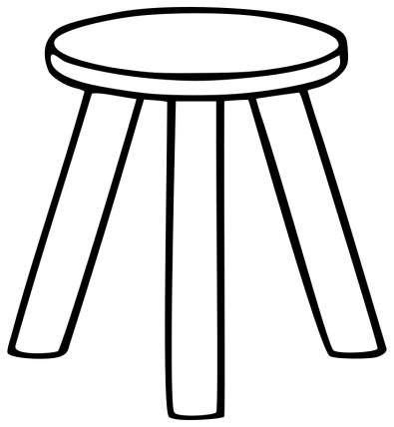
Claim
Evidence
Evidence

Evidence

2.) What are the ASSUMPTIONS (hidden beliefs the argument rests on)?
Sometimes an argument looks really strong: there is a clear claim, supported by relevant evidence. But if the argument rests on a faulty assumption, the entire argument collapses. Using the stool metaphor, the glue that is used is weak. The stool looks fine until someone sits on it, and the stool falls apart.

Claim: Men are better leaders than women.
Evidence:
- There are more male than female leaders in all major fields: business, politics, education, and the military.
- Across cultures and throughout history, men are celebrated and remembered for their leadership.
- The “Founding Fathers” of our country are all men.
Reasoning: The only way that men could achieve all of these things is if they are better leaders. If women were great leaders, we would see many more of them in positions of leadership, both in the past and now.

Sample Questions
- Find Out More Evidence:
  - How, if at all, does the path to leadership differ for men and women – now and in the past?
  - Which, if any, fields have more female leaders than male leaders?
  - When have women been celebrated for their leadership?
  - Who determines when someone becomes a “leader?”

- Define Terms:
  - How are you defining “leader?”
  - What are the qualities of a “good” leader?

- Define Philosophy/Beliefs:
  - Are leaders “born” or “made?”
  - What is specific to men that makes them better leaders than women?

An argument resting on a faulty assumption:
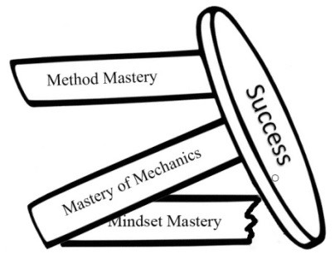
Evidence

Evidence

Evidence

Claim

