Claim:
- A debatable statement
OR
- A statement that must be proven before you accept it as true (this type of claim is often used in math)

What Makes a Strong Claim?
As a student, you need to learn how to make your own claims and support them with evidence. A strong claim is:
- Debatable
- Supportable
- Clear
- Specific

Examples
- Fall is the best season.

- Abraham Lincoln was our country’s best president.

- If you want to be an architect, geometry is the most important subject in school for you to learn.

- The main theme of Black Boy is perseverance through challenge.

- Come up with your own:
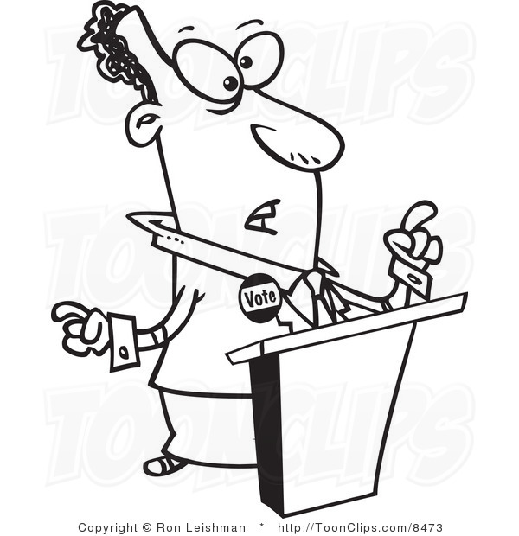
My Client is Innocent!
My product is the best!
I have discovered the cure!
You should vote for me!

